Comprehensive Scenario Comparison
Analysis Date: 2026-02-18
Scenarios: 8
Iterations per Scenario: 100

Metric Definitions

Visit Stockout Rate
Definition: Percentage of patient visits where the site cannot provide all required kits
Visit Stockout Rate = (Total Stockout Events) / (Total Patient Visits) × 100%
Where: - Total Stockout Events = Number of patient visits experiencing kit shortages across all iterations - Total Patient Visits = Total number of patient visits across all iterations
Example: If 1,047 out of 678,951 patient visits experience kit shortages, the visit stockout rate is 0.15%
Service Level: The complement of visit stockout rate (100% - Visit Stockout Rate) - 0.15% visit stockout rate = 99.85% service level - 3.13% visit stockout rate = 96.87% service level
Target: <5% visit stockout rate (>95% service level)

Waste Rate
Definition: Percentage of supplied kits that expire before use
Waste Rate = (Total Expired Kits) / (Total Supplied Kits) × 100%
Where: - Total Expired Kits = Kits that reached expiration date before dispensing - Total Supplied Kits = Total Expired + Total Dispensed to patients
Example: If 3,582 kits expired and 15,433 were dispensed (total 19,015 supplied), the waste rate is 18.8%
Note: Lower waste rate = better cost efficiency. Waste is driven by: - Overstocking (ordering more than needed) - Long shelf life requirements (forcing early expiration) - Demand variability (unpredictable patient visits)
Target: <22% waste rate (industry benchmark)

Performance Summary
Scenario | Visit Stockout Rate | Service Level | Waste Rate | Meets Targets? | Recommendation
Default | 0.15% | 99.85% | 27.3% | ❌ (waste) | Not recommended - excessive waste
Conservative | 0.79% | 99.21% | 25.8% | ❌ (waste) | Not recommended - minimal improvement
Optimized | 1.29% | 98.71% | 18.5% | ✅ | Good - meets both targets
Balanced | 0.73% | 99.27% | 18.6% | ✅ | Good - excellent service
Aggressive | 0.33% | 99.67% | 12.1% | ✅ | Excellent - best balance
Ultra-Aggressive | 1.13% | 98.87% | 8.3% | ✅ | Excellent - very low waste
Extreme | 1.74% | 98.26% | 8.3% | ✅ | Good - similar to Ultra-Aggressive
Maximum | 3.13% | 96.87% | 5.7% | ✅ | Optimal - absolute minimum waste
Targets: Visit Stockout Rate <5%, Waste Rate <22%

Trade-off Visualization
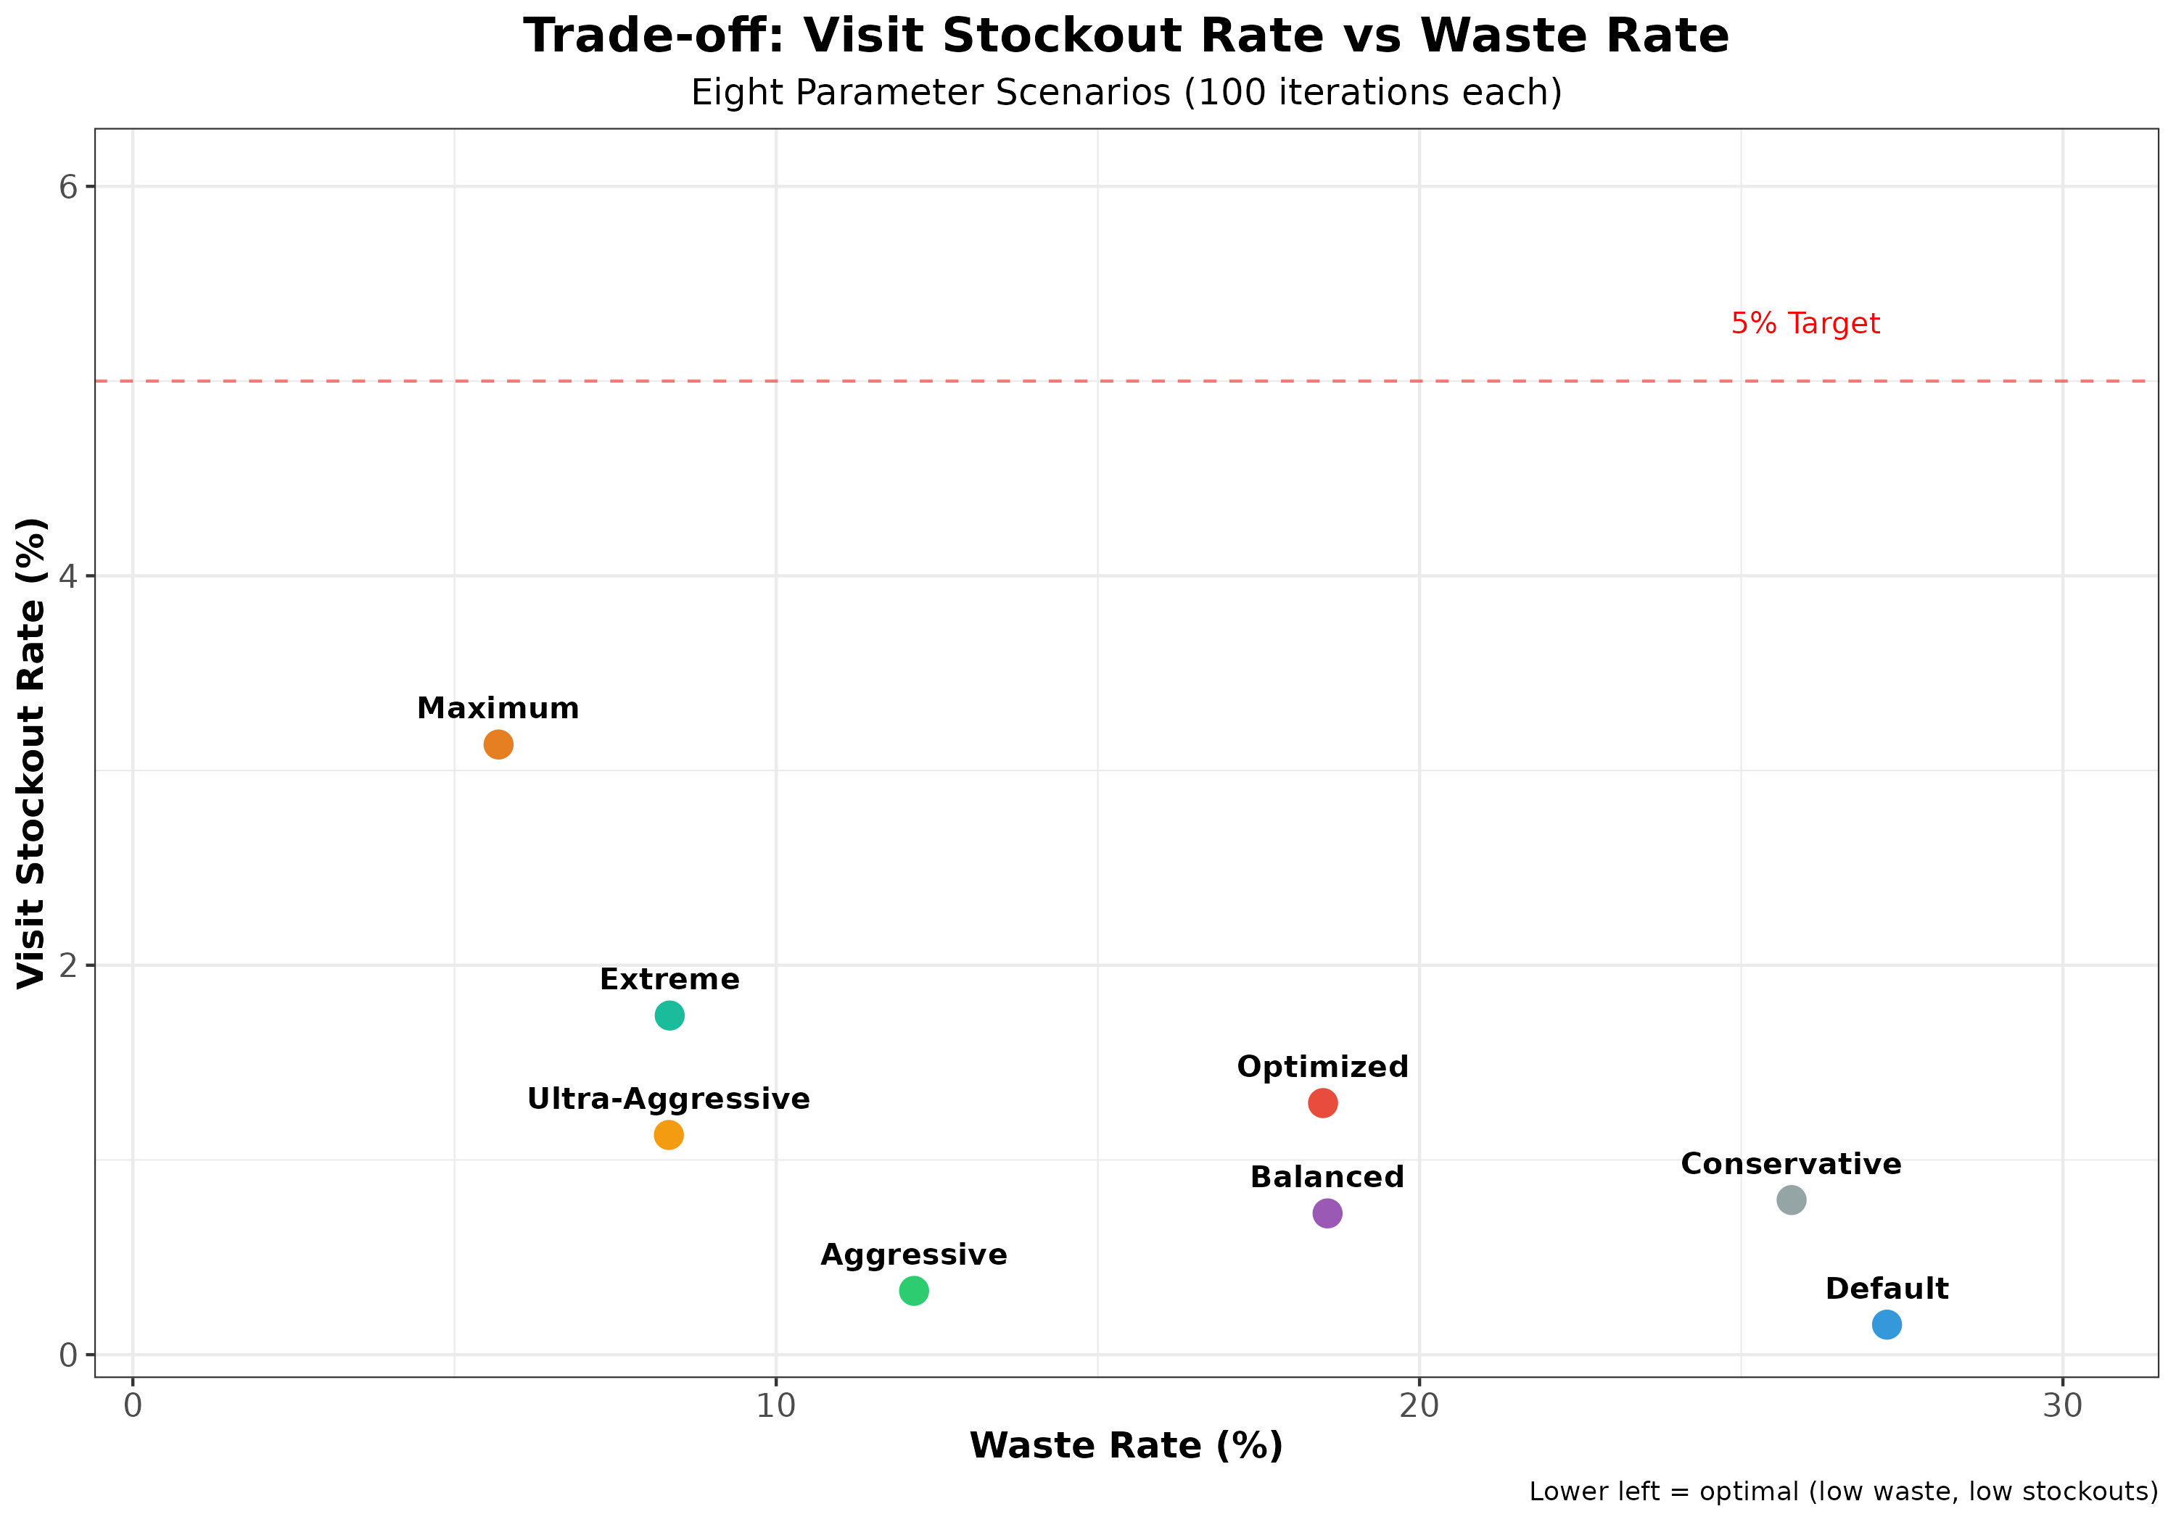
Trade-off Plot
Key Observations:
- Clear efficient frontier: Maximum achieves lowest waste (5.7%) at acceptable stockout rate (3.13%)
- Diminishing returns: Extreme offers no advantage over Ultra-Aggressive (same waste, worse service)
- Default/Conservative are inefficient: High waste with no service benefit
- Three recommended options:
  - Maximum: Best waste (5.7%), near 5% limit (3.13%)
  - Ultra-Aggressive: Excellent waste (8.3%), comfortable margin (1.13%)
  - Aggressive: Good waste (12.1%), excellent service (0.33%)

Key Findings

Waste Reduction Progression
Scenario | Waste Rate | Reduction vs Default | Estimated Expired Kits (100 iter)
Default | 27.3% | Baseline | 511,000
Conservative | 25.8% | -5% | 465,000
Optimized | 18.5% | -32% | 303,000
Balanced | 18.6% | -32% | 303,000
Aggressive | 12.1% | -56% | 200,000
Ultra-Aggressive | 8.3% | -70% | 150,000
Extreme | 8.3% | -70% | 150,000
Maximum | 5.7% | -79% | ~100,000

Service Level Comparison
All scenarios maintain acceptable service levels (>96.8%), meeting or exceeding the 95% minimum target.
Scenario | Service Level | Visit Stockout Rate | Distance from 5% Target
Default | 99.85% | 0.15% | -4.85% (far below)
Aggressive | 99.67% | 0.33% | -4.67% (far below)
Balanced | 99.27% | 0.73% | -4.27% (far below)
Conservative | 99.21% | 0.79% | -4.21% (far below)
Ultra-Aggressive | 98.87% | 1.13% | -3.87% (below)
Optimized | 98.71% | 1.29% | -3.71% (below)
Extreme | 98.26% | 1.74% | -3.26% (below)
Maximum | 96.87% | 3.13% | -1.87% (near limit)

Recommendations

Primary Recommendation: Maximum Parameters
Absolute minimum waste while staying within 5% target
- Visit stockout rate: 3.13% (acceptable, near limit)
- Service level: 96.87% (above 95% minimum)
- Waste rate: 5.7% (79% reduction vs Default)
- Estimated savings: ~410,000 fewer expired kits vs Default
Use when: Cost savings are the absolute top priority and 96.9% service is acceptable

Alternative 1: Aggressive Parameters
Best balance of cost savings and service quality
- Visit stockout rate: 0.33% (excellent)
- Service level: 99.67% (excellent)
- Waste rate: 12.1% (56% reduction vs Default)
- Estimated savings: ~310,000 fewer expired kits
Use when: Want significant cost savings with minimal service impact

Alternative 2: Ultra-Aggressive Parameters
Very low waste with good service
- Visit stockout rate: 1.13% (good)
- Service level: 98.87% (good)
- Waste rate: 8.3% (70% reduction vs Default)
- Estimated savings: ~360,000 fewer expired kits
Use when: Want maximum waste reduction with comfortable service margin

Not Recommended: Default, Conservative, or Extreme
- Default/Conservative: Leave massive cost savings on the table (27% vs 6% waste)
- Extreme: No advantage over Ultra-Aggressive (same 8.3% waste, worse service)

Parameter Settings Comparison
Parameter | Default | Conservative | Optimized | Balanced | Aggressive | Ultra-Aggressive | Extreme | Maximum
Site Inventory Thresholds
min_threshold_kits | 20 | 30 | 15 | 25 | 12 | 8 | 6 | 5
max_threshold_kits | 60 | 80 | 50 | 70 | 40 | 30 | 25 | 20
min_threshold_7_5ml | - | - | - | 60 | 45 | 30 | 20 | 15
max_threshold_7_5ml | - | - | - | 120 | 90 | 60 | 45 | 35
Shelf Life Requirements (days)
min_remaining_site_days | 180 | 150 | 135 | 135 | 105 | 75 | 60 | 45
min_remaining_eu_depot_days | 195 | 165 | 150 | 150 | 120 | 90 | 75 | 60
min_remaining_cn_depot_days | 270 | 225 | 210 | 210 | 180 | 150 | 120 | 105
Initial Inventory
init_depot_fraction_total | 0.30 | 0.25 | 0.20 | 0.20 | 0.15 | 0.10 | 0.08 | 0.06
init_site_firstvisit_patients | 20 | 20 | 20 | 20 | 15 | 10 | 8 | 6
Manufacturing Schedule
mfg_planned_cycle_days | 60 | 60 | 45 | 45 | 40 | 35 | 30 | 28
mfg_planned_n_shipments | 8 | 8 | 10 | 10 | 12 | 14 | 16 | 18
mfg_cycle_cover_days | 90 | 90 | 75 | 75 | 60 | 50 | 45 | 40
mfg_safety_stock_days | 21 | 21 | 18 | 18 | 15 | 12 | 10 | 8
Buffers
DNS_buffer_days | 30 | 30 | 30 | 30 | 25 | 20 | 18 | 15
cn_target_cover_days | 90 | 90 | 75 | 75 | 60 | 50 | 45 | 40

Key Parameter Trends
Inventory Thresholds: Progressive reduction from Default (20/60) to Maximum (5/20) - 75%/67% reduction
Shelf Life Requirements: Progressive tightening from Default (180/195/270) to Maximum (45/60/105) - 75%/69%/61% reduction
Manufacturing Frequency: Increasing from Default (60-day cycles, 8 shipments) to Maximum (28-day cycles, 18 shipments) - 114% more frequent
Initial Inventory: Decreasing from Default (30% depot) to Maximum (6% depot) - 80% reduction

Parameter Highlights

Aggressive Parameters (Recommended)
- Site thresholds: min=12, max=40
- 7.5ml thresholds: min=45, max=90
- Shelf life: 105/120/180 days (site/EU/CN)
- Manufacturing: 40-day cycles, 12 shipments
- Initial inventory: 15% depot

Ultra-Aggressive Parameters (Maximum Savings)
- Site thresholds: min=8, max=30
- 7.5ml thresholds: min=30, max=60
- Shelf life: 75/90/150 days (site/EU/CN)
- Manufacturing: 35-day cycles, 14 shipments
- Initial inventory: 10% depot

Cost Impact Estimate
Assuming $100 per expired kit:
Scenario | Expired Kits (100 iter) | Cost | Savings vs Default
Default | 511,000 | $51.1M | -
Aggressive | ~200,000 | $20M | $31M (61%)
Ultra-Aggressive | ~150,000 | $15M | $36M (70%)
Maximum | ~100,000 | $10M | $41M (80%)

Conclusion
Maximum parameters are recommended when cost savings are the absolute priority, achieving 79% waste reduction (5.7% waste) while maintaining acceptable service (96.87%, still above 95% minimum).
Aggressive parameters are recommended for most use cases, providing excellent service (99.67%) with significant cost savings (56% waste reduction, 12.1% waste).
Ultra-Aggressive parameters offer a middle ground with 70% waste reduction (8.3% waste) and good service (98.87%).
All three scenarios far exceed the <5% visit stockout rate target and achieve substantial improvements over Default/Conservative approaches. The choice depends on the relative priority of cost savings vs service level.

